MIPS Assembly and Digital Logic Circuits

Paul Collado

Department of Computer Science

Montclair State University

CMPT280

Assembly Language

11/25/2014

Exercise 1:

1. Problem:

Write a simple MIPS Assembly program for a NOT (Inverter) gate

1. Test data: 1 and 0
2. Print the resulting outputs
3. Solution:
4. Analysis:

I approach this problem by using and XOR logical operator, I take the 1 or 0 and XOR it with 1 and the result is always the contrary of my initial variable

1. Program code:

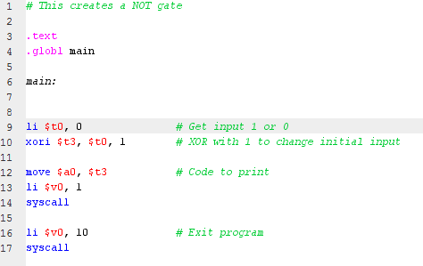

1. Example:

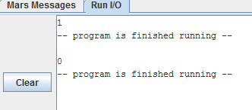

Exercise 2

1. Problem :

Write two Simple MIPS Assembly programs to simulate the following, (a) and (b), logic expressions:

1. X = AB + A’C

* Test data: A = 1, B = 0, C = 1
* Print the output X
* Verify the result with LogiSim

1. Y = ABC + D

* Test data: A = 1, B = 0, C =1, D = 0
* Print the output Y
* Verify the result with LogiSim

1. Solution :

PART (a)

1. Analysis:

For this problem, I enter the values for A, B and C, then I used the XOR to convert A into A’, then I just did an AND on (A \* B) and (A’ \* C) separately and then finally I OR the results [ (A\*B) + (A’\*C)], then I just printed it and also Created the gates on LogiSim to prove my answer

1. Program code:

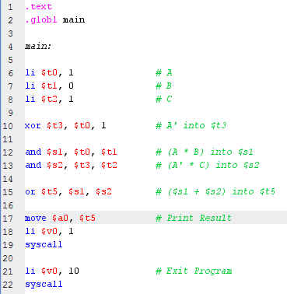

1. Example:

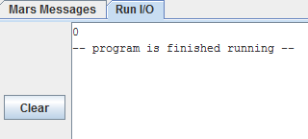

1. LogiSim:

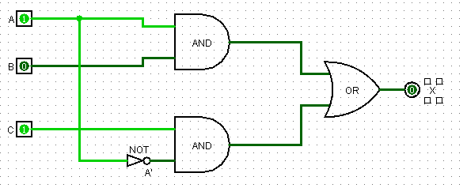

PART (b)

1. Analysis :

For this problem, I enter the values for A, B C, and D, then I AND it (A\*B) then I AND it the Result with C [(A\*B)\*C]; after having the result for that part I OR it with D [(ABC) + D]. Finally I just printed the result and exited the program

1. Program code:

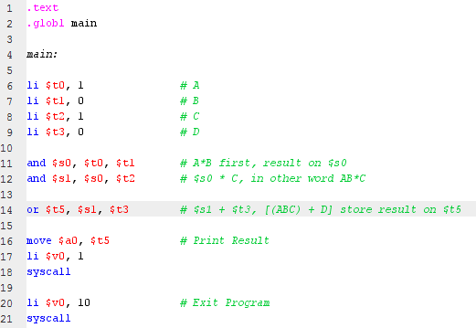

1. Code example:

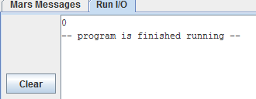

1. LogiSim:

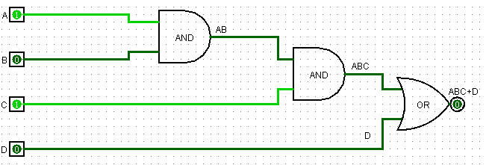

Exercise 3

1. Problem:

Write a MIPS Assembly program for a Digital Logic Circuit of your Choice:

* Print the resulting output
* Verify the result with LogiSim

My Choice is:

(A+B)\*(C+D)

1. Solution
2. Analysis:

I approached this problem by first loading all variables, then OR (A+B) and (C+D) and finally I AND these two answers, print them and exit the program

1. Program code:

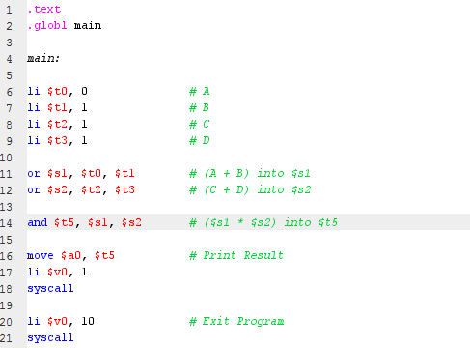

1. Example:

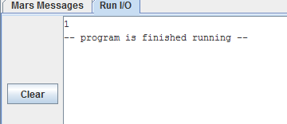

1. LogiSim:

